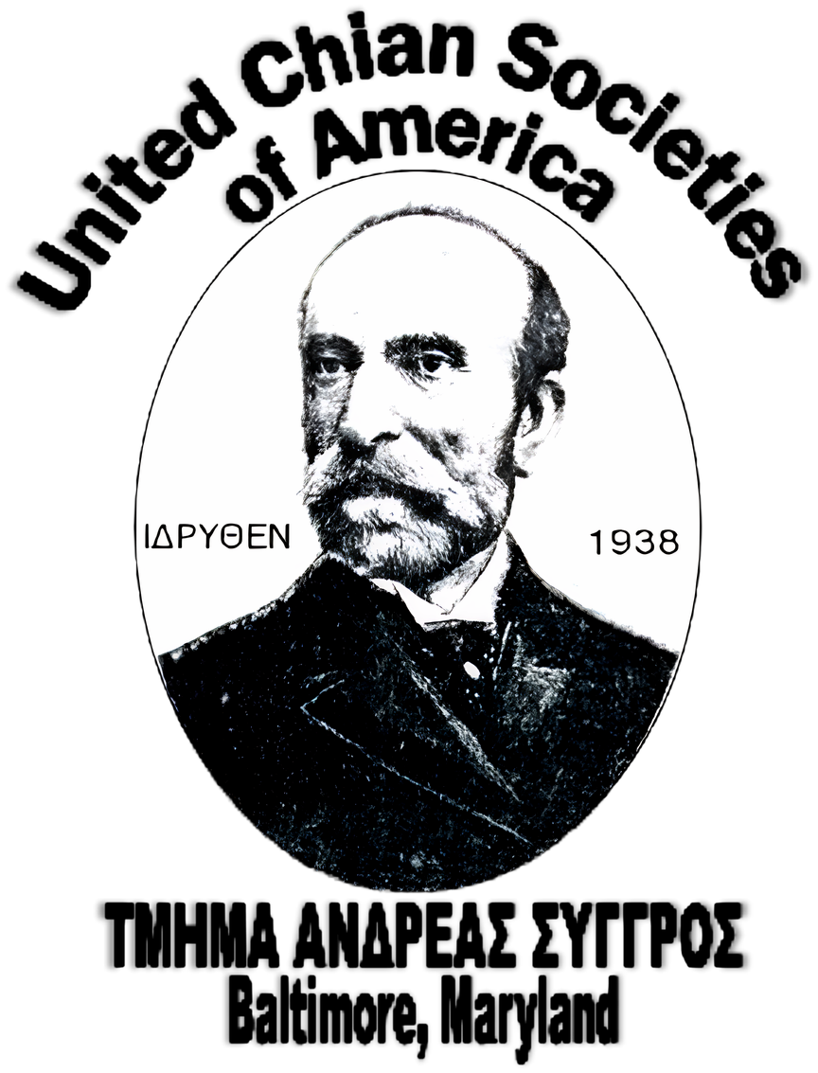
2026 Scholarship Application
United Chian Societies of Baltimore
“Andreas Syggros” And
Ladies Panchian Society

Dear Applicant,
PLEASE READ THE FOLLOWING INSTRUCTIONS CAREFULLY BEFORE COMPLETING YOUR APPLICATION.
To be eligible for this scholarship, you MUST meet the following criteria:
- Be an undergraduate student only.
- Be a full-time student at an accredited institution (college, university, or accredited trade/vocational school) (Please note: College seniors and graduate students are not eligible)
OR
- Be a high school senior planning to attend an accredited college, university, or trade/vocational school.
- The applicant or their family must be a steward in good standing of the Cathedral of the Annunciation, Sts. Mary Magdalene & Markella, St. Demetrios, St. Nicholas, and/or
St. Theodore.
Required Application Materials
- Please ensure all of the following documents are included. Incomplete applications will not be considered.
  - Official transcripts (see notes below if your school does not use traditional grading or GPA)
  - A typed essay on the topic provided.
  - Any additional supporting documents you wish to include.
  - A photo
  - Letter of Recommendation
Submission Guidelines
- Your completed application must be mailed to:
United Chian Societies of Baltimore
“Andreas Syggros” and Ladies Panchian Society
P.O. Box 1092
Cockeysville, MD 21030
- All materials must be received no later than July 1, 2026.
- The entire application must be typed; handwritten applications will not be accepted.
- If you have any questions, please do not hesitate to contact the Scholarship Chairpersons:
Sandie Skordalos and Kiki Stroumbis at scholarships@chios.us
Scholarship recipients will be publicly announced on July 19, 2026, at:
St. Nicholas Greek Orthodox Church
520 Ponca Street
Baltimore, MD 21224
All recipients will be notified directly with details regarding the award ceremony.

***Only applications mailed and received by July 1, 2026, will be accepted. No Exceptions! ***

ATTACH A RECENT  PASSPORT SIZE  PHOTO OF YOURSELF |  | MAIL TO:  United Chian Societies of Baltimore  “Andreas Syggros” and Ladies Panchian Society  P.O. Box 1092  Cockeysville, MD 21030
***THIS ENTIRE APPLICATION PACKAGE BECOMES THE PROPERTY OF THE UNITED CHIAN SOCIETIES OF BALTIMORE AND WILL NOT BE RETURNED***
PLEASE TYPE ALL INFORMATION INTO THIS DOCUMENT
- Name of Applicant: _________________________________________________________________
Last First MI
- Mailing Address: ___________________________________________________________________

- Telephone Number: (___________) __________________________________
- Date of Birth: ________/________/___________
- E-mail: ___________________________________________________________________________
- What is your anticipated major / focus:
_________________________________________________________________________________
- Name of the College/University/Trade School you will attend in the Fall of 2026:
________________________________________________________________________________
________________________________________________________________________________
City State Zip

- How is the applicant affiliated with the United Chian Societies of Baltimore “Andreas Syggros”
and/or Ladies Panchian Society Family? (Please CHECK one)
- ______ I am a son, daughter, grandson, or granddaughter of a member in good standing of either
the United Chian Societies of Baltimore “Andreas Syggros” or Ladies Panchian Society.
- ______ I am a son, daughter, grandson, or granddaughter of a deceased member of either the United Chian Societies of Baltimore “Andreas Syggros” and/or Ladies Panchian Society.
- ______ I am a member in good standing of the United Chian Societies of Baltimore “Andreas
Syggros” and/or Ladies Panchian Society.
- ______Not Affiliated.
- CREDENTIALS REQUIRED:
- Your High School/College credentials must be mailed with your application and all other documents and received by July 1, 2026:
United Chian Societies of Baltimore
“Andreas Syggros” and Ladies Panchian Society
P.O. Box 1092
Cockeysville, MD 21030
- HIGH SCHOOL SENIOR:
    - High School Transcript, Class Rank, Grade Point Average (GPA).
- COLLEGE UNDERGRADUATES:
  - College Transcript and Grade Point Average (GPA).
If your school does not have GPAs, Ranks, or traditional grading, please provide a letter from a school administrator (guidance counselor, academic advisor, etc.) stating this. The administrator should provide a “mock GPA,” if possible.
- A TYPED list of all honors, awards, achievements, extracurricular activities, Dean’s List, honor societies membership (ex. NHS) you have received. You may list all the clubs and organizations you are a member of as well.
- A TYPED list of employment history to include part and/or full-time employment.
- A letter of recommendation from a teacher or a community leader/priest, etc.
- Essay with the following criteria:
- TYPED double-spaced with one-inch margins.
- Between 350 - 450 words.
- Times New Roman Font with Font size 12 point.
- Include a TITLE heading.
- Check your spelling/grammar.
- NOTE: NO AI assisted essays will be accepted.
- ESSAY PROMPT (TOPIC):
Describe what being of Chian and/or Hellenic heritage means to you. Who has influenced you the most in shaping your connection to this heritage? Please also include your involvement in your community, church, and/or Chian chapter, and explain how this award will support your goals.
- What are the total expected expenses for your next (first) year of college?
$________________________
- To what extent are your parents able to cover your college expenses?
Tuition $____________________________, Room & Board $____________________
Books & Supplies $___________________, Transportation $____________________
- State the combined annual parental income: $ __________________________________
- State your annual income: $ _________________________________________
- Please total your estimated college expenses for one year.
- Tuition $ ________________
- Books $ ________________
- Room & Board $ ________________
- Transportation $ ________________
- Other $ _______________
TOTAL $ ________________
- Estimated Resources for next school year:
- Family help $ ________________
- Employment $ ________________
- Savings $ ________________
- Loans $ ________________
- Other $ ________________
TOTAL $ ________________
- Have you applied for financial aid through FAFSA? Yes ( ) No ( )
- If YES, what type of aid are you receiving or expecting to receive?
_____________________________________________________________________________________
- Have you applied for financial aid at your college/university? Yes ( ) No ( )
- If YES, what aid are you receiving or expecting to receive? ________________________________
- Please explain: __________________________________________________________________
- Do you anticipate receiving any outside scholarships? Yes ( ) No ( )
- If YES, source: _________________________________________________ Amount ___________

- Please cite any special considerations that would help the committee in making adecision in your favor. ___________________________________________________________________________________
___________________________________________________________________________________
___________________________________________________________________________________
- Please sign, include all required documentation and mail to: United Chian Societies of Baltimore
“Andreas Syggros” and Ladies Panchian Society P.O. Box 1092 Cockeysville, MD 21030
Use your hand-written signature.
All documention must received by July 1, 2026
By signing below, I verify that everything I have submitted is true to the best of my knowledge and belief. I do understand that if the scholarship committee finds any information in this application that is falsified, my candidacy for this scholarship will be forfeited. I understand that I must contact the Scholarship Committee chairpersons by email (scholarships@chios.us) should I have any questions in regards with my application.
________________________________________ STUDENT SIGNATURE  ________________________________________  PARENT/GUARDIAN SIGNATURE (if under 18) | _________________________ DATE  _________________________  DATE

________________________________________
PARENT NAME PRINT (if under 18)

APPLICANT CHECKLIST
This is for your own usage; You do not need to submit this page.
If you can successfully check off everything in this list, your application will be acceptable for review.
- Have you included your academic transcripts submitted? ______
- Have you included a copy of your SAT/ACT scores (if available)? ______
- Have you included a typed list of awards, honors, accomplishments, and/or extra-curricular activities? ______
- Have you included a typed list of part time work (if applicable)? ______
- Have you included a typed essay? ______
  - Have you followed all the criteria for the essay? ______
- Have you included a photo? ______
- Have you included a letter of recommendation? _______
- Have you signed the application? ______
- Have you double checked that you filled out each question in the entire application? ______

GRADING SCALE
The committee will use the following scale to grade your application. This is only for your reference.
The format for grading is:
Academics 40 points
Essay 20 points
Letter of Recommendation 10 points
Work/Extra-Curricular Activities 15 points
Direct Affiliation with the United Chian Societies of Baltimore Family 15 points

Total 100 points

